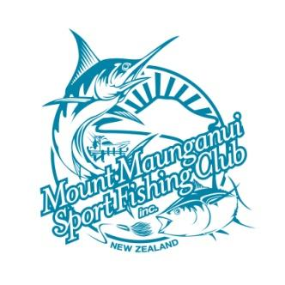 | TOURNAMENT SCHEDULE
 | 2023/2024

INTERCLUB 16th-17th September 2023

MMSFC Golf Comp 22 October 2023

Hamills Trout 24-26 November 2023

Col’s Butchery Ham’s Comp 2-3 December 2023

DECORO Blue Water Classic 22nd - 24th February 2024

Nationals 17 - 24 February 2024

New World Ladies 22nd - 23rd March 2024

Davy Construction Juniors 6 April 2024

Youth Nationals 13-28 April 2024

Winter Series May 2024

Killwell Sports Trout 14-16 June 2024

Tuna Sweepstakes 1st June - 31st August 2024
(Albacore; Bluefin)
Port Side Auto Services

